# Pymaceuticals Inc.

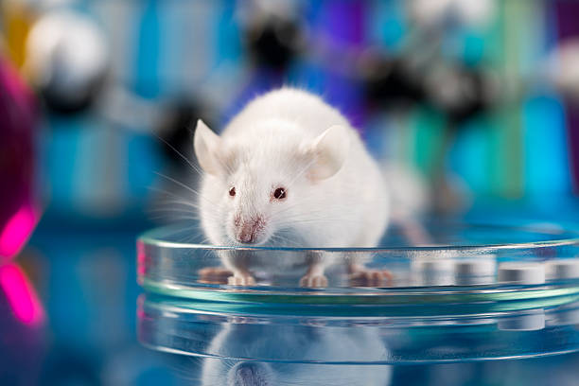

**Removed duplicated mice using unique and clean function.**

The total number of mice is 248.

**Generated bar plot showing the total number of timepoints for all mice tested for each drug regimen using pandas and pyplot**.

* The bar graph showed the Drug Regimen Capomulin has the maximum mice number (230), and Propriva has the smaller mice number (182).

**Generate a pie plot showing the distribution of female versus male mice using Pandas and Pyplot**

The total count of mice by gender showed that 124 female mice and 125 male mice.

**Calculated the IQR and quantitatively determined if there are any potential outliers.**

**Generated a line plot of tumor volume vs. time point for a mouse treated with Capomulin**

From the selected treatments Capomulin reduces the size of tumors better.

**Generated scatter plot of average tumor volume vs. mouse weight for the Capomulin regimen**

The correlation between mouse weight, and average tumor volume is 0.84. It is a strong positive correlation, when the mouse weight increases the average tumor volume also increases.

**Calculated the correlation coefficient and linear regression model for mouse weight and average tumor volume for the Capomulin regimen.**

* The regression analysis helped to understand how much the average tumor volume (dependent variable) will change when weight of mice changes (independent variables). The R-squared value is 0.70. Higher R-squared values represent smaller differences between the observed data, and the fitted value. 70% the model explains all the variation in the response variable around its mean.

**Observations**

* There were more trials done for certain drugs than others, so the information is skewed. Capomulin, Ramicane ,Ketapril, and Naftisol had more # of trials than other drugs given.

**Other comments:**

When doing the Summary statistics question, particularly when I used the mean and median functions, I received an error that the function was deprecated. I had to google it and later discovered that it required a numeric_only = true parameter.

Had difficulty solving the linear and regression model had to google and referred various sources to answer the question.